1. Plug the USB from the 2D scanner into the computer and the toggle end into the scanner itself.
2. Position the scanner so that a subject could easily step straight up onto the platform and then step straight off. A nearby wall or person standing next to the scanner can be used for balance.
3. Turn on the scanner. On the desktop, under all programs, search and open EverspryOS.

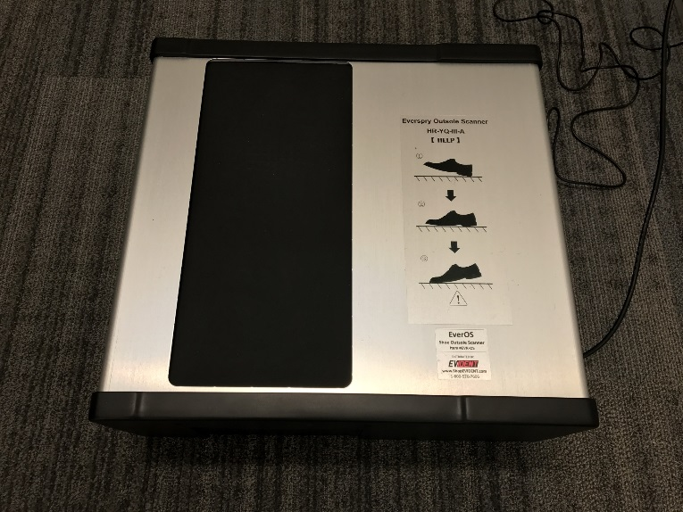

**Power Cord Connector**

**On/Offf Switch**

**USB Computer Connector**

1. Before the subject steps up onto the platform, make sure that the acquisition screen is blank and free of previous prints.

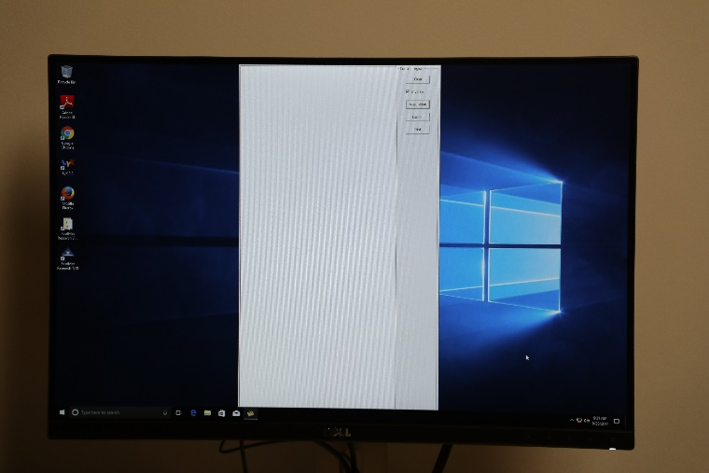

1. When stepping up onto the scanner, the subject should place their heel on the scanner with their toe pointing towards the ceiling. They will then roll their foot into a flat standing position and step up so that all of their weight is on the scanner.

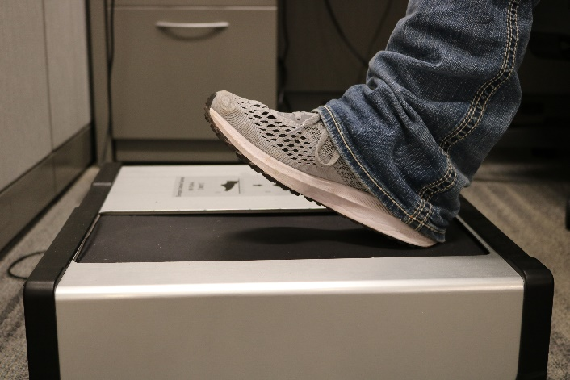

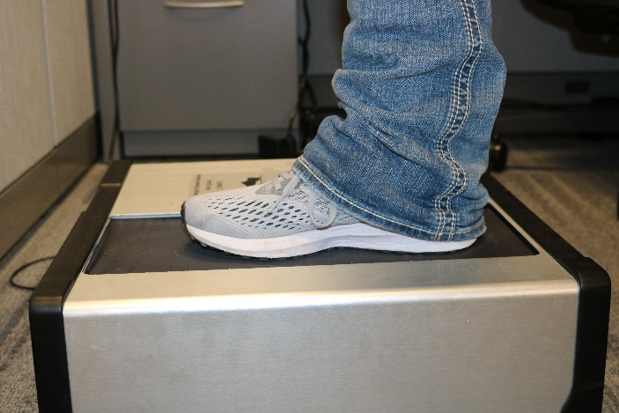

1. Have the subject shift their weight in the shoe in order to capture all detail possible.
2. Carefully, have the subject step off of the scanner. Peel the foot forward until only the tip of the toe is making contact with the platform. At this point, lift the foot straight up, off of the scanner.

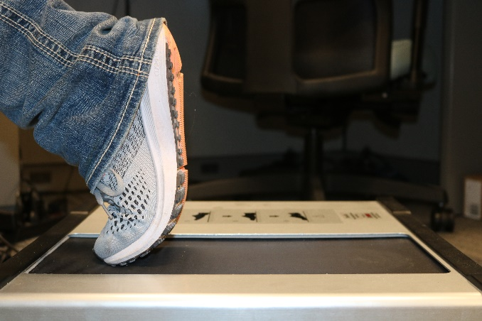

1. Review the print on the

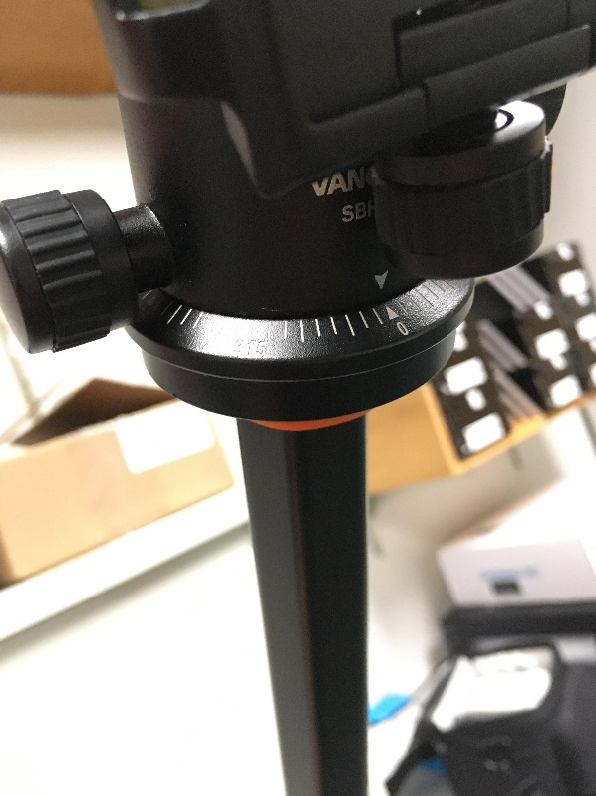

1. Screw the Quick Shoe into the bottom of the camera

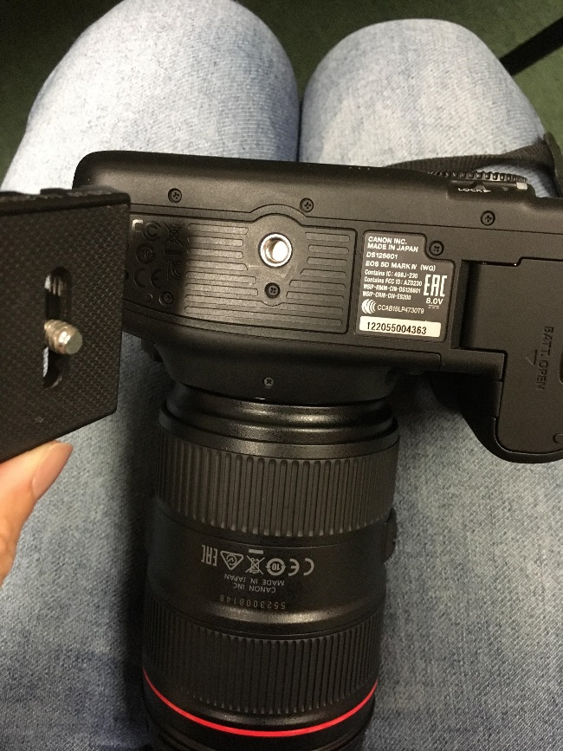

1. Loosen Knob F and slide the Quick Shoe (located on the bottom of the camera) into place on the tripod. Then tighten Knob F
2. Loosen Knob C and rotate the ball on the tripod head until the camera lens is parallel to the ground. Use the green level to ensure the camera is parallel. Then tighten Knob C

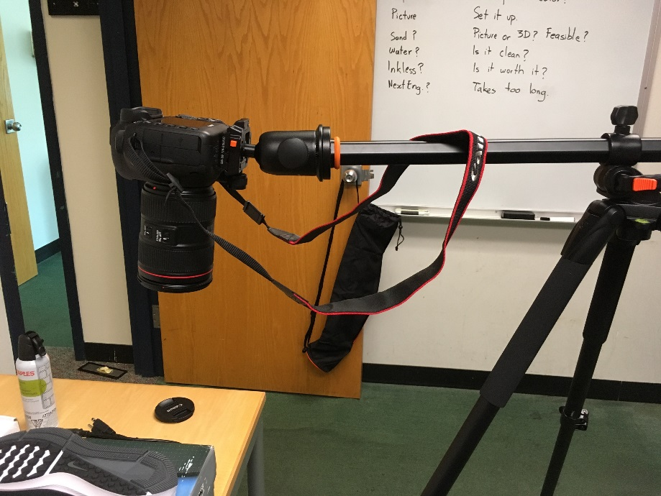

1. Position the tripod legs so that the camera is directly above the shoe
2. To adjust the camera lens, move the switch on the camera from “Lock” and rotate the lens to the suitable zoom setting